Lab 06 - Install OpenLDAP

Introduction
During this lab you will be installing directory services. There are many directory services you could use but we'll be using OpenLDAP in this lab. The goal of this lab is to teach you how to manage a list of users and learn how to authenticate server/user access through the directory server you'll now set up.

Tasks:
- Configure the deployed machine
- Install and configure OpenLDAP
- Configure client machines

Remember, from this lab forward you automatically have a base snapshot to revert to if you have things go horribly wrong. Also, remember to take snapshots as you work through the labs.

Configure Deployed Machine
- Configure the new virtual machine that has been deployed to you.
  - The machine is named cpre230_[netid]_ldap_server.
  - The username and password are cpre230.
  - Power on the machine.
  - Set the hostname to ldap with the following command.
sudo hostnamectl set-hostname ldap
  - Reboot. Confirm the hostname by running the hostname command.
  - You should now have network access. Issue ip addr. Ping the default gateway of 192.168.1.1.
  - Verify you can update and upgrade your ldap_server. If the machine is unable to update itself, it means there is a networking problem that needs to be fixed before moving on. Again, you need to double check your configuration files and use Google to troubleshoot before asking the TAs for help.

Assign MAC Address Reservation for ldap_server
If you do an ip addr you will see that your machine now has a randomly assigned IP out of the range of 192.168.1.190-192.168.1.198. HOWEVER, you want ldap_server to always be assigned the same IP address when it does dhcp so you are going to set up a MAC address reservation for it just like you did for the desktop machine.
- Using your desktop machine, log into pfSense. If you don’t remember how to do this return to Lab 04
- Set a MAC address reservation. If you don’t remember how to do this, return to Lab 05.
- The fields that need to be filled out are listed below

MAC address | IP address | Hostname | Description
From vSphere client | 192.168.1.205 | ldap | Ubuntu server - ldap

- Reboot the ldap server. Check your IP address with ip addr. Save a screenshot for your lab report.

SLAPD Installation and Configuration
We will be using the slapd utility (Stand-alone LDAP Daemon) to provide authentication for our network. This will be the service that will allow "single-sign-on access" on many of our boxes.

- Be sure you are on the ldap server.
- Install slapd via apt. Use sudo apt install slapd
  - You will be prompted for an administrator password. For simplicity’s sake make this cpre230.
- Install ldap-utils (for querying and debugging), similarly to how you installed slapd.
(Might already be installed)
- Configure slapd via sudo dpkg-reconfigure slapd and answer the following questions:
- Omit OpenLDAP server config? No
- DNS domain name studentXX.230.com
- Organization name studentXX
- Administrator password password used for 2.a
- Remove when purged? No
- Move old database? Yes

- Test your configuration
  - ldapsearch -x -LLL -H ldap:/// -b “dc=studentXX,dc=230,dc=com” dn
  - You should see something similar to the following response. NOTE: This may only output one line. Take a screenshot for your lab report.
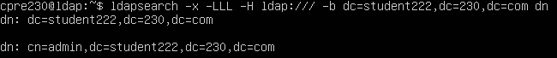

LDAP Account Manager

Install LDAP Account Manager
To manage the groups and users in the LDAP database, we will install LDAP Account Manager (LAM). LAM is a web-based management tool, so you will interface with it through a web browser. To install LAM, run the following command.

sudo apt install ldap-account-manager

Configure LDAP Account Manager
After the install is finished, move to your Ubuntu desktop virtual machine. Open http://ldap.studentXX.230.com/lam (or try http://192.168.1.205/lam) in Firefox on your Ubuntu desktop virtual machine. 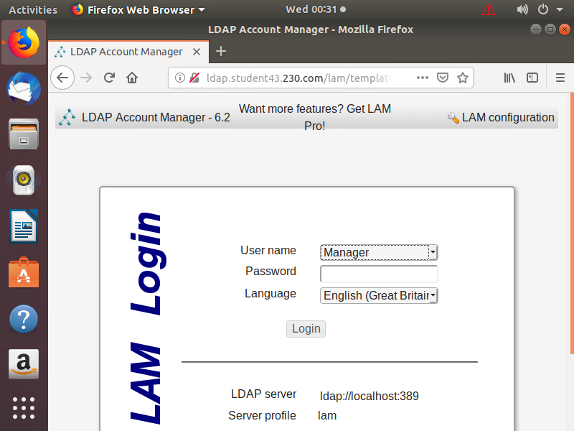
LAM must be configured to connect to the LDAP server. To do this, click "LAM configuration" in the top right corner of the login screen. Then click "Edit server profiles". Enter the default password "lam", as in the first three lowercase letters of the word, “lamb”. Leave all settings at their default values, except the following.

- "General settings" tab
  - "Tool settings" section
    - Tree suffix: "dc=studentXX,dc=230,dc=com"
  - "Language settings" section
    - If you like, you can switch the language and time zone, but it's not necessary.
  - "Security settings" section
    - List of valid users: "cn=admin,dc=studentXX,dc=230,dc=com"
  - "Profile password" section
    - Here you can change the password that protects these LAM profile settings, but it's not needed and it is definitely easier for the TAs to troubleshoot if you don’t change the password.
- "Account types" tab (at the top of the page)
  - "Active account types" section
    - "Users"
      - LDAP suffix: "ou=People,dc=studentXX,dc=230,dc=com"
    - "Groups"
      - LDAP suffix: "ou=group,dc=studentXX,dc=230,dc=com"

Save these settings (at the bottom of the page, you may have to resize the window to see it), and you should be returned to the login page. Log in with the administrator password you created when installing slapd.

At this point, LAM is installed and configured and your LDAP database is set up, but contains no users or groups yet.

Creating Groups and Users
We will now create groups and users for single-sign-on.

- If you don't have it still open, open http://ldap.studentXX.230.com/lam and log in.
- When asked if you want LAM to create the LDAP suffixes, click "Create".
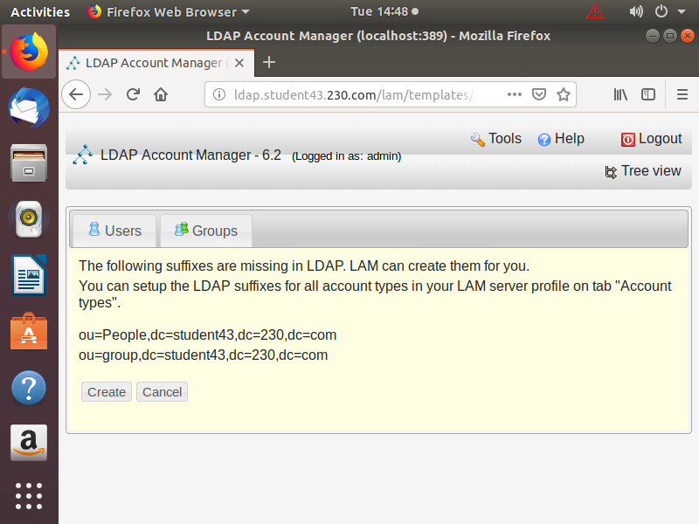
- Select the "Groups" tab.
- Create three groups by clicking "New group" (or "Create another group").
  - The groups should be named "Admin", "Finance", and "Developers".
  - Click "Save" after entering each group name.
- Select the "Users" tab.
- Create new user accounts.
  - The user accounts you need to create are specified on this spreadsheet.
- "Personal" tab
  - Only enter first and last name.
- "Unix" tab
  - Double check the user name and common name. They should be correct by default.
  - Select the primary group specified in the spreadsheet.
  - Set the home directory to what's specified in the spreadsheet. (Note that $user will be replaced with the username automatically.)
- Click "Set password" and enter the password specified in the spreadsheet.
- Save the account.
- Go back to the users list to review the users you created.
  - Take a screenshot of the created users.
- Verify that you can authenticate from a terminal on your Ubuntu Desktop.
  - sudo apt install ldap-utils
  - ldapwhoami -vvv -H ldap://ldap.studentXX.230.com -D "cn=Bill Gates,ou=People,dc=studentXX,dc=230,dc=com" -x -w “windowz”
  - You should get a message saying “Result: Success (0)”. Take a screenshot of this.
  - Notice that we have not integrated any of our clients to LDAP yet. As we add more services, we will enroll them.

Configuring the SSO Workstation
- Use the new ldap workstation (new desktop machine) that was deployed to you.
  - VM name: cpre230_[netid]_ldap_workstation
  - Credentials: cpre230/cpre230
  - Be sure to use the ldap workstation, not the server.
  - Set the MAC address reservation on the pfsense box for the workstation. You can use the table below. If you don’t remember how to do this, the steps are found in Lab 05.

MAC address | IP address | Hostname | Description
From vSphere client | 192.168.1.207 | workstation | Ubuntu desktop - workstation

  - Power on (or restart) the workstation. Verify it got the correct IP address using ip addr.
  - Update and upgrade your desktop. If the machine is unable to update itself, it means there is a networking problem that needs to be fixed before moving on.
  - Change the hostname to workstation.
sudo hostnamectl set-hostname workstation
  - Connect this box to the LDAP server by following the guide here.
- When logging into the ldap workstation after rebooting, use the "Not listed?" option on the login screen (below cpre230 generally), log in as Bill Gates (bgates).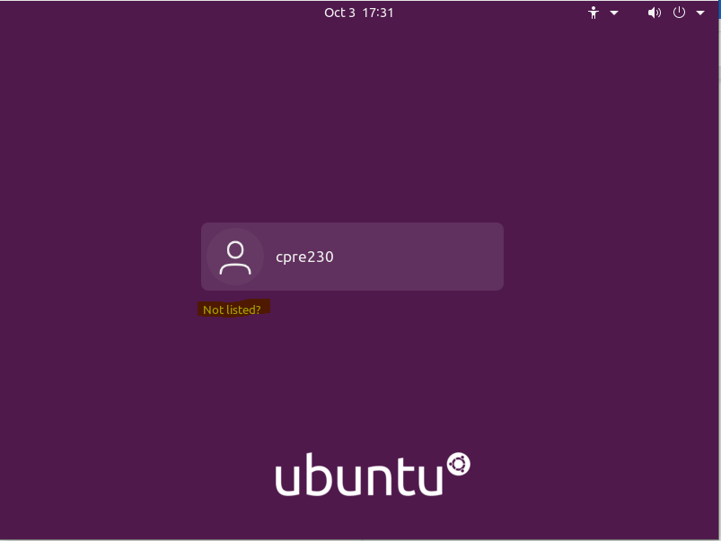
  - Open a terminal and run the id command.
  - Take a screenshot.

Add Rules for Nagios ldap Check
- From your desktop machine open Firefox and open the pfSense web configurator. If you don’t remember how to do this, return to Lab 04.
- Add a NAT rule in pfSense that allows Nagios to check the ldap connection. You can use the instructions from Lab 05 to determine what fields to complete, but you will need to know what protocol to use, as well as the correct IP addresses and ports. If you have questions, you can ask your TA for help. However, you should begin to be able to think through these options on your own.
- Go to Nagios and check if it can see your service. Recall the instructions in Lab 05. You may have to adjust your firewall rule if you are unsuccessful.
- Include a screenshot of your successful NAT rule.
- Include a screenshot of the Nagios queries showing green in your lab report.

